**Assignment No 1**

**Combination**

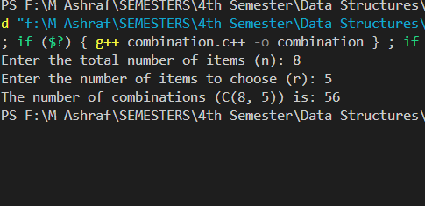

**Permutaion**

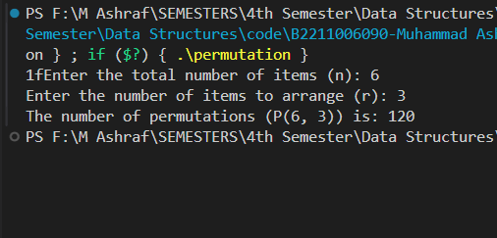

**Assignment No 2**

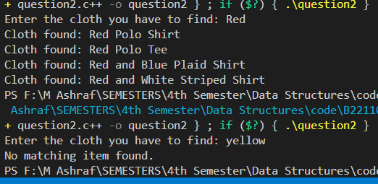

**Assignment No 3   
  
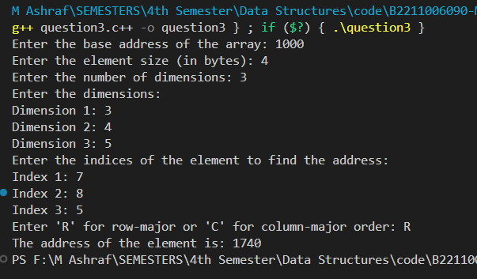**

**Assignment No 4**

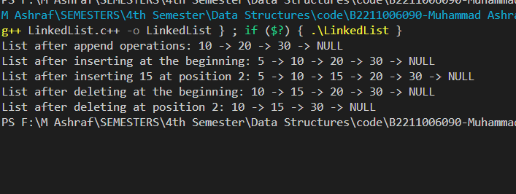

**Assignment No 5**

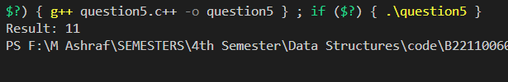

**Assignment No 6**

**QueueUsingArray**

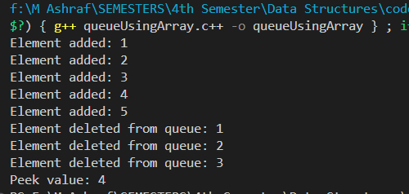

**QueueUsingLinkedList**

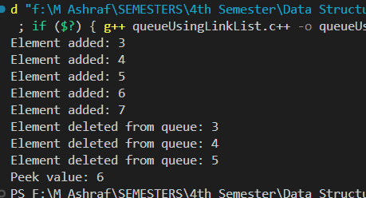

**StackUsingArray**

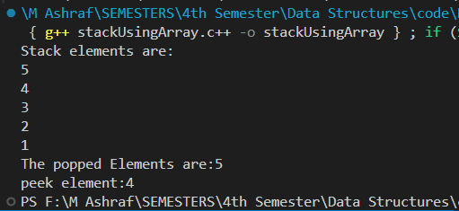

**StackUsingLinkedList**

